This content is meant to address several concerns that may affect men at any age, with a particular focus on common concerns of college-aged men. The content focuses on topics covering sexual health, urinary function, testosterone, sperm, scrotal/testicular pain, and penile size. We discuss what some of these concerns are, what can be done to improve them, and when someone should consider discussing with a healthcare provider.

Sexual health
Sexual function concerns include anything and everything having to do with erectile function, orgasm, ejaculation, and sexual desire.

Let’s begin with the basics of penile anatomy and how the penis works.
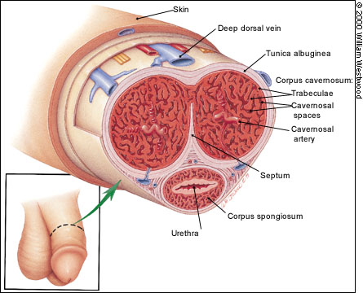
The penis is made of three tubes. There are two connected erectile bodies that are made of a sponge-like tissue, called the corpus cavernosum, and the tube containing the urethra, which is found below the erectile bodies. It is helpful to think of the erectile tissue like a sponge.

Blood supply to the erectile tissue comes from the cavernosal artery (which goes to each erectile body). The diameter of a cavernosal artery is about the size of the tip of a pen.
Figure 1: Cross sectional anatomy of the penis (Miller 2020)

Arousal leads to the release of nitric oxide which causes the blood vessels in the penis (cavernosal artery) to enlarge. Increased blood fills the spongy tissue, causing it to expand (much like a sponge absorbing water). Expansion of the cavernosal tissue causes the surrounding veins to be squeezed shut, preventing blood from leaving the penis, which maintains an erection. This works much like filling a bathtub with water. By using the drain plug, you prevent water from leaving and the tub fills. Once you pull the plug, water goes down the drain and the tub empties (which is similar to what happens when the veins open back up and blood leaves the erectile bodies, resulting in a flaccid penis).

Daily erections are important to help maintain the health of the penile tissue, whether or not the erection is used for sexual activity. When erections stop occurring on a daily basis, it is important to assess ones’ health and behaviors to see if there is something that might be causing daily erections to no longer occur, as this could be a symptom of an underlying health problem.

Erectile dysfunction (ED)
Erectile dysfunction refers to difficulty getting and/or maintaining an erection.

Because the blood vessels that go to the penis are small, anything that prevents these blood vessels (arteries) from opening enough to increase blood flow to the penis may lead to worsening erectile function.

Medical conditions can cause blood vessel problems, and, therefore, ED. These conditions include high blood pressure, diabetes, and high cholesterol.

Another cause of erectile dysfunction can be venous leak. Referring back to the tub analogy, if you have a fully functioning faucet, but you lack a drain plug, the bathtub won’t fill up because the water will drain out of the tub. Diabetes, scar tissue in the penis, and anxiety can prevent these veins from adequately closing off. Lastly, it is possible for someone to have problems with both the arteries (blood coming into the penis) and the veins (blood leaving the penis)– a weak faucet and a leaky drain plug.

Drug use:
Various types of drugs (including over-the-counter and prescription drugs) can worsen erectile function by reducing blood flow to the penis. These include:
Cigarette smoke
Nicotine-containing products
Cocaine
Amphetamines (including meth, methylphenidate, and MDMA)
Marijuana: There are conflicting theories on the effect of marijuana on erectile function, but frequent marijuana use is associated with lower sperm counts, trouble achieving orgasm, and increased risk of ED.
Alcohol: Small amounts of alcohol have not been shown to cause ED. Excess alcohol, however, reduces nitric oxide and is associated with ED.

Medications:

Antidepressants:
Common medications used to treat depression are within a class of medications called Selective Serotonin Reuptake Inhibitors (SSRIs). Examples include citalopram (Celexa), escitalopram (Lexapro), fluoxetine (Prozac), paroxetine (Paxil), and sertraline (Zoloft). These medications raise the level of serotonin in the body. Side effects of these medications may include low sexual desire, difficulty getting or maintaining an erection, and delayed or inability to reach orgasm. Talk to your healthcare provider about potential sexual side effects before starting these medications, or if you have noticed sexual dysfunction after starting these medications. If interested in stopping antidepressant therapy, discuss gradually decreasing your dose with your prescribing healthcare provider to minimize risk of experiencing withdrawal-like symptoms.

Antihistamines:
Common medications to treat allergy symptoms (coughing, sneezing, watery eyes), nasal congestion, motion sickness, and acid reflux are within a class of medications called antihistamines. These medications are available over-the-counter and by prescription. Examples include diphenhydramine (Benadryl), hydroxyzine, loratadine (Claritan), cetirizine (Zyrtec), fexofenadine (Allegra), famotidine (Pepcid), ranitidine (Zantac), dimenhydrinate (Dramamine). Histamine plays a role in healthy erections and, therefore, antihistamines may contribute to ED.

Attention-Deficit/Hyperactivity Disorder (ADHD)/Attention Deficit Disorder (ADD) Medications:
Common medications to treat attention ADHD and ADD are within a class of medications called stimulants. These medications are available by prescription. Examples include methylphenidate (Ritalin, Concerta) and dextroamphetamine-amphetamine (Adderall).

Psychological factors: Emotions like happiness, sadness, frustration, and excitement can impact how other parts of the body function (or don’t function). Performance anxiety, which is stress associated with the perceived expectation to perform, often impacts a person’s ability to function sexually. Stress from work, previous psychological traumas, or generalized anxiety can impact erectile function. Elevated anxiety and stress can lead to elevated levels of neurotransmitters that prevent erection, such as norepinephrine and epinephrine. Elevated levels of stress can also cause muscles in the pelvis (which are critical to getting and maintaining erection, experiencing orgasm, and ejaculating), to not function appropriately, leading to sexual dysfunction. Speaking with a mental health provider to learn and master relaxation techniques can be an incredible tool to optimize sexual function.

Nutrition: Nutrition plays an important role when it comes to sexual function. Inflammation, which can result from eating certain foods, can speed up the destruction of nitric oxide and can contribute to issues getting and maintaining erection. There are many factors that impact the release of nitric oxide in the body, including what we eat. The good news is that simple dietary changes can improve male sexual health.

Foods high in antioxidants, such as Vitamins C and E, have been shown to improve erectile function by preventing damage to cells that produce nitric oxide. Vitamin C can be found in fruits and vegetables such as oranges, strawberries, bell peppers, broccoli, and cauliflower. Vitamin E can be found in plant-based oils, nuts, seeds, fruits and vegetables including asparagus, mango, and avocado.

Limiting intake of red meat, added sugars, trans-fats and replacing with fruits, vegetables, nuts, oily fish, and whole grains can dramatically decrease inflammation and promote overall improved sexual health in men.

Exercise: When it comes to erectile function, in general, whatever is good for the heart is good for the genitals. Exercise has been shown to improve erectile function while sedentary lifestyles have been shown to impair erectile function.

There are many ways to optimize erectile function. Consuming mostly whole-food, plant-based nutrition, exercising, limiting drug and alcohol use, and being mindful of how psychological factors impact sexual health can all optimize sexual function. Additional treatment options are also available.

The main ED treatment categories include medications, devices, and surgery.

Medications: There are four Food and Drug Administration approved medications for ED, which include sildenafil (Viagra), tadalafil (Cialis), vardenafil (Levitra), and avanafil (Stendra). These medications function by preventing the breakdown of nitric oxide in the body (recall that nitric oxide is a molecule that opens up the blood vessels that go to the penis). These medications are generally taken as needed, prior to wanting to get an erection and are typically the first medication used to improve erectile function.

If the pill medications don’t work or cause side effects, other options include medication that goes directly into the urethra or is injected with a small needle into the side of the penis.

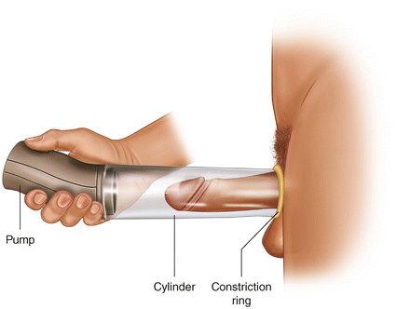
Devices: Vacuum erection devices are placed around the penis and create a negative pressure to “suck” blood into the penis. These devices can be used prior to sexual activity or as part of a penile rehabilitation protocol (to maintain health of penile tissue).

Penile constriction bands can be used alone, with medication, or with a vacuum erection device to help keep blood in the penis to maintain an erection.
Figure 2: Vacuum pump device (2017)
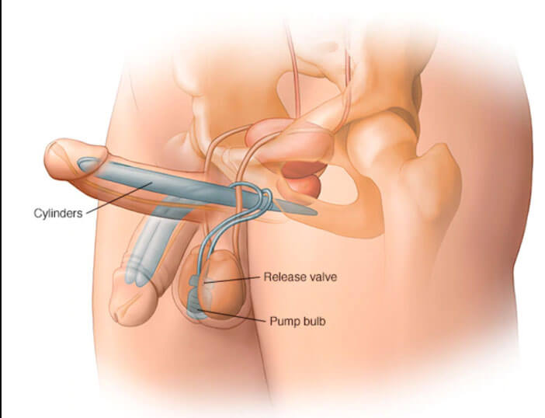
Surgery: Penile implants can be placed in the operating room. These implants are completely concealed within the body (a cylinder is placed in each erectile body, a pump is placed in the scrotum, and a storage balloon is placed in the pelvis).

Penile implants are typically placed in men who aren’t able to get adequate erections with other therapies for ED. Penile implant surgery provides rigidity on-demand, though is not a lengthening procedure.
Figure 3: Penile prosthetic implant (Tyagi 2019)

Orgasm and ejaculation are two separate processes!

Orgasm is largely a brain event typically triggered by genital stimulation, but it can be induced by stimulation of other body parts. It is marked by a sensation of intense pleasure and relaxation that is associated with sexual climax. This is caused by a massive release of neurotransmitters, specifically oxytocin and dopamine, in the brain.

Orgasm disorders are often caused by medications that affect neurotransmitters. This can include SSRI’s, which increase serotonin levels in the brain, SNRI’s, which increase both serotonin and norepinephrine, as well as recreational drugs. Recreational drugs typically affect levels of serotonin and dopamine, which is why they provide a sensation of “euphoria.” However, by artificially influencing levels of these neurotransmitters, they can influence, delay, and block orgasm entirely.

Ejaculation is the contraction of pelvic and penile muscles to expel semen. Semen can shoot out, dribble out, or not come out at all (termed “dry ejaculation”). Quality of ejaculation varies between men and can vary in a single man on different occasions. Ejaculation is often associated with orgasm, but they can occur independently of one another.

Ejaculation problems exist on a spectrum of ejaculating too early, too late, having painful ejaculations, or not ejaculating at all. Ejaculation involves the contraction of muscles in the pelvis. In order for semen to be expelled from the penis, there is a rhythmic contraction of the pelvic floor musculature that “sucks” semen into the urethra and then “ejects” it out of the penis. Disorders of the pelvic floor can delay ejaculation, cause painful ejaculation, or cause involuntary premature ejaculation.

Premature Ejaculation is when ejaculation occurs earlier than a man wishes during a sexual encounter. Clinically, it is defined as ejaculation within 60 seconds of penetration. It is not considered a problem unless it is associated with significant distress. Over-the-counter topical anesthetics (delay sprays) and condoms can be helpful to reduce penile sensation to prolong time to ejaculation. Sensate focus, referring to touching exercises that focus on non-orgasm related touch and sensations like temperature, texture, and pressure, can also be a useful tool.

Delayed Ejaculation is the inability to achieve ejaculation or an excessive delay in time to ejaculation, despite sufficient sexual stimulation and the desire to ejaculate. There is no definition of what constitutes “delayed” ejaculation. Time to reach ejaculation varies between men and may vary for the same man on different occasions.

Hematospermia is the presence of blood in the semen. It may be pink or bright red. Blood in the semen in young men typically goes away on its own. Evaluation by a healthcare provided is warranted if the blood is associated with symptoms of infection (like pain with urination, blood in the urine, urethral discharge, etc), concern for an STI, any concerns for a testicular mass, or if the hematospermia persists and/or contains a significant amount of blood.

Retrograde Ejaculation occurs when, instead of the semen coming out of the tip of the penis at time of ejaculation, it flows in the opposite direction, into the bladder. Common causes of retrograde ejaculation are medications used to help men urinate (like tamsulosin), as well as after prostate surgery.

Anejaculation refers to the absence of ejaculation with climax and may occur after a neurologic injury.

Anorgasmia refers to the inability to reach orgasm despite adequate sexual stimulation.

Anhedonic orgasm is when ejaculation occurs, but there are no feelings of pleasure, intimacy, or relaxation. It is often associated with medication use, particularly antidepressants.

Painful Ejaculation is when there is pain with or after ejaculation. This pain can be felt anywhere in the pelvis/genitals, including the perineum (area in between the rectum and back part of the scrotum), one or both testicles, in the penis and/or urethra. Some men describe a spasm-like tightening in the pelvis and describe changes in ejaculate (fluid takes a while to come out of the tip of the penis and/or drips out). Because the process of ejaculation involves the contraction of pelvic floor muscles, painful ejaculation is often related to pelvic floor muscle dysfunction (for which seeing a pelvic physical therapist can be helpful). If the urinary stream is also very weak, there could be scar tissue (stricture) in the urethra, for which evaluation by a urologist is recommended.

Sexual desire/libido
Interest in sexual activity (solo’d or partnered) varies between people and changes throughout ones’ lifetime. There is NO right amount of sexual desire for any person. Low sexual desire, if not bothersome, is not a problem.

Low sexual desire may become a concern if it impacts a person’s quality of life or causes relationship problems.

There are many causes of low sexual desire in young men. Medications, such as SSRI’s, can lower libido by affecting neurotransmitter levels in the body. Drugs, such as cocaine, nicotine, alcohol, and marijuana, can reduce sexual desire by altering neuronal pathways and lowering hormonal levels (such as testosterone). Hormonal problems, such as imbalances during puberty or due to illness/disease, can affect libido. Psychological factors, such as stress, anxiety, depression, and mood disorders are often associated with decreased sexual drive and can be improved by speaking with a counselor and optimizing ones’ mental health.

Meeting with a counselor alone or with a partner, particularly with a counselor able to discuss sexual health and pleasure, can be very helpful. Given medications are common reasons for changes in libido, paying attention to one's body and how one feels on/off certain medications is also important. Changes in sexual desire, if bothersome, may be reason-enough to discuss with ones’ healthcare provider about other non-medication and medication therapies with fewer known sexual health side effects.

Sexually transmitted infections (STIs)
Anyone engaging in any type of partnered sexual activity is at risk of STIs. Much of preventing the spread of STI’s depends on open conversations between partners regarding their history. Either asking a partner for their history, or opening up first about your prior diagnoses, can set the stage to having an honest conversation and prevent the spread of STI’s.

Suggestions for bringing up conversations related to partnered sexual activity and STI’s:
- When were you last tested for STIs?
- Let’s limit the risk of either of us getting an STI. Let’s use protection.
- I previously had gonorrhea from an ex of mine. I got treated and recently was tested and am all negative. Have you been tested recently?
- I care about your health and mine. Let’s get tested for STI’s together.

STI’s can spread via blood (intercourse or shared needles), bodily fluids (semen, saliva, vaginal secretions), or skin to skin contact (genitals, anus, mouth). Symptoms may include painful urination, rashes, itching, blisters, sores, lumps, or discharge, but men may be completely without symptoms and unaware that an STI may be present.

STI testing is often performed via blood (HIV, syphilis, hepatits B, hepatitis C) and/or urine (gonorrhea, chlamydia, trichomoniasis) sample. Gonorrhea and chlamydia can also be present in the throat and rectum so swabs of these areas may also be obtained. Urethral swabs are often not needed in men to diagnose an STI.

It is perfectly acceptable to be tested (screened) for STI’s for anyone who is sexually active even in the absence of any STI symptoms or known sexual partners with/history of STI’s.

Other infections that can affect the genital and/or urinary system include jock itch or yeast infection. Symptoms may include groin rash, itching, and burning. Men may also get urinary tract infections (UTI; bladder infections). Symptoms of a UTI include genital/flank pain, burning during urination, increased urinary frequency, and/or dark/cloudy urine. Changes in urine smell and/or color may be due to dehydration or certain food/drink intake and do not necessarily mean that a UTI is present. If a UTI is suspected, evaluation/urine testing by a healthcare provider is recommended so appropriate antibiotic treatment can be prescribed, if needed.

Sex talk
Suggestions for bringing up conversations related to partnered sexual activity:
- What feels good?
- What does good sex look like?
- When were you last tested for STIs?
- How comfortable are you communicating your level of pleasure/displeasure during sex?
- Do you have any sexual goals/dreams/fantasies?
- What excites/scares you about sex?

Streams

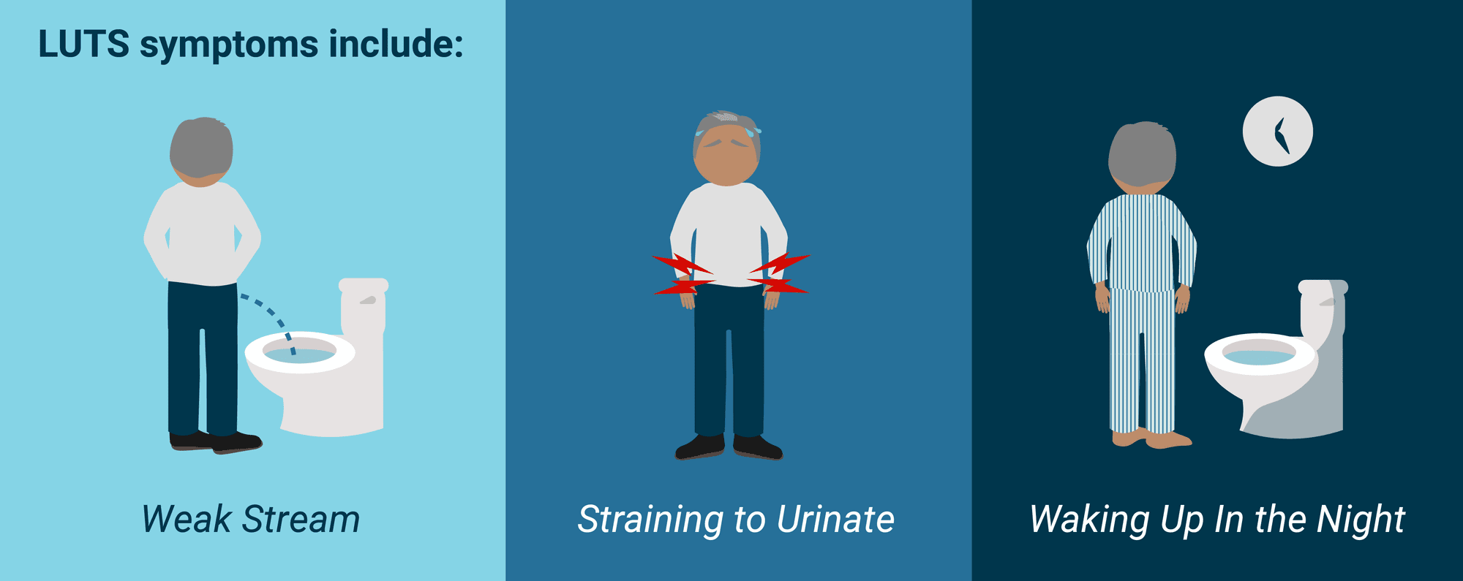
The lower urinary tract includes the bladder and urethra. Part of the urethra goes through the prostate, an organ that sits deep in the pelvis and surrounds the urethra as it leaves the bladder. The prostate is a like a donut and you urinate through the donut hole. The prostate serves two important functions. First, it helps nourish sperm and second, it is surrounded by nerves that, when stimulated, can lead to sexual pleasure. Three main things can happen to the prostate. First, it can become inflamed and/or infected (“prostatitis”). Second, it can grow due to non-cancerous reasons and cause a blockage of urine as it leaves the bladder (“benign prostatic hyperplasia” or BPH). Third, it can develop prostate cancer.
Figure 4: Lower urinary tract symptoms (LUTS) (2020)

Importantly, even though the prostate often gets blamed for bothersome urinary symptoms in men, it is not always the prostate’s fault.
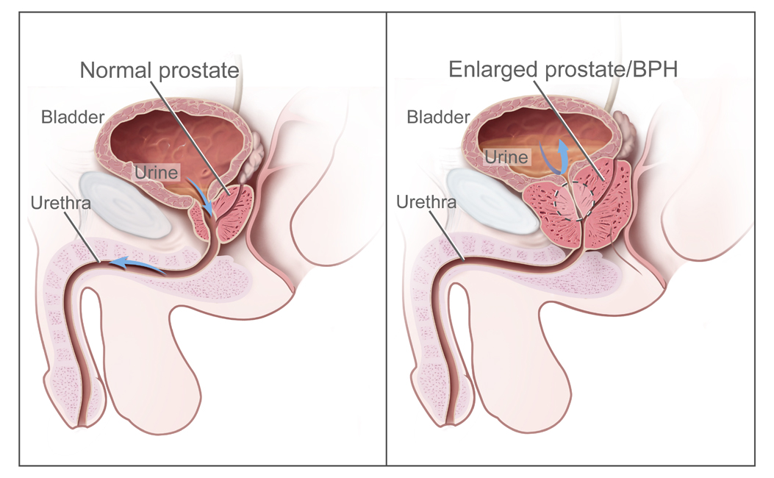
In young men, bothersome urinary symptoms due to an enlarged prostate and/or prostate cancer are very unlikely. The prostate gets bigger with age though typically does not cause urinary symptoms until a man is in his 50’s. Prostate cancer is one of the most common cancers diagnosed in men, though affects older men. Most men will develop prostate cancer as they get older, but most will not die from this disease. Prostate cancer screening is typically performed with a blood test. Men between 55 and 69 years of age have been shown to get the greatest benefit from prostate cancer screening.
Figure 5: Normal prostate (left), benign prostatic hyperplasia (right) (2022)

More common causes of bothersome urinary tract symptoms in young men include urinary tract infections, urethral stricture (scar tissue in the urethra that causes a narrowing and often presents with weak urinary stream and having to strain to urinate), constipation, oral intake of fluids, environmental factors, and/or pelvic floor dysfunction.

Certain fluids, such as juices, soda (pop), coffee, and alcohol are known urinary tract triggers. In other words, your body is reacting normally to what you put in it. Decreasing intake of these irritants and replacing them with water can reduce the sudden urge to have to urinate and the frequency of urination. Alcohol and coffee, in particular, are common causes of urinary symptoms (urgency and frequency) in college-aged men.

Pelvic floor muscle dysfunction is often thought of as a problem in women, as they may deliver babies through their pelvic floor. However, pelvic floor dysfunction is also common in young men. The pelvic floor muscles are like a hammock of muscles that surround the rectum, penile tissue, and urethra. They are also what rhythmically contract during ejaculation. Symptoms of pelvic floor dysfunction include urinary urgency, frequency, post void dribbling (dribbling of urine out of the urethra once you finish urinating), urinary leakage, constipation, scrotal/testicular pain, perineal (“prostate”) pain, pain with ejaculation, constipation, and/or erectile dysfunction. Scheduling a visit(s) with a pelvic physical therapist (physical therapists with particular expertise in the male pelvic floor) can be an incredible way to improve many of these symptoms.

Steroids
When people think about steroids, including testosterone, they often think about their misuse in sports and bodybuilding. Steroids are modified testosterone molecules that are used to increase muscle mass. They are considered to be performance-enhancing drugs and are typically banned by various athletic associations. Steroids are not inherently bad, however, and they perform very important functions.

To understand what testosterone supplementation does to the body, we have to first understand the basics of testosterone production. One part of the brain (hypothalamus) sends signals to another part of the brain (anterior pituitary gland) which then sends signals to cells in the testicles to produce sperm and testosterone. The testosterone produced by the body then functions as a “stop” signal for the brain, telling the brain when there is adequate production of testosterone.
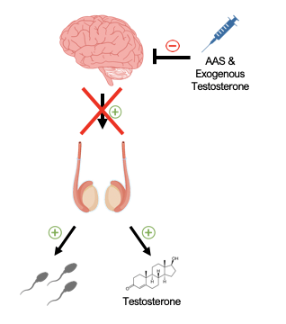
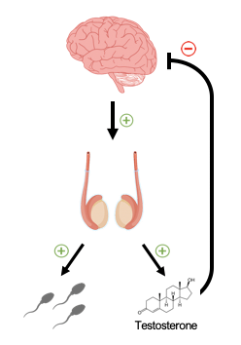

Figure 6: Normal testosterone feedback (left), effect of AAS and exogenous testosterone (right)
Testosterone supplementation (referred to as “exogenous” testosterone), acts as a “stop” signal to the brain to shut down one’s own ability to produce testosterone (and this may also make it difficult to have children as it can shut down sperm production). The testicles often shrink given the brain is no longer sending as much signal to the testicles to produce testosterone or sperm. Some testosterone also gets converted to estrogen. Estrogen actually plays an important role in men, but when estrogen levels are too high, can cause bothersome side effects, which include breast tenderness or swelling, mood changes, fluid retention, fatigue, worsening erections, and/or worsening sex drive. It is especially important for young men to understand the implications of testosterone supplementation on the body.

Selective Androgen Receptor Modulators (SARMs) are becoming more common and function by binding to testosterone (androgen) receptors in specific tissues. These SARMs are, in theory, more tissue specific. They are not approved by the Food and Drug Administration (FDA) and, therefore, what the packaging says they contain, may not actually be what the product contains.

It is important to distinguish performance-enhancing drugs from actual low levels of testosterone, which may warrant treatment. Most men will experience a decline in their testosterone levels after 30 to 40 years of age, though young men in their late teens and twenties may also have legitimately low testosterone levels. Common symptoms of low testosterone (which are also common with other medical conditions) include reduced energy, fatigue, reduced endurance, diminished work and physical performance, loss of body hair, reduced beard growth, reduced lean muscle mass, obesity, depressive symptoms, cognitive dysfunction, reduced motivation, poor concentration, poor memory, irritability, reduced sex drive, and/or reduced erectile function. The diagnosis of low testosterone is made with two morning testosterone levels (blood tests) in combination with the symptoms presented. It is important to seek healthcare provider guidance if concerned about having low testosterone as self-treating with SARMs or testosterone supplements without consulting your healthcare provider can result in significant short- and long- term side effects.

Hair loss
Hair loss (male-pattern balding or androgenetic alopecia) is a common concern in men of all ages, including young men and can be a very frustrating experience. Half of Caucasian men, for example, are affected by age 50. Hormones (androgens) and genetics play major roles in hair loss, so it is common for this to run in families (meaning, if one’s father experienced balding, sons are at higher risk of this, as well). It is thought that this form of hair loss is due to an excessive response to hormones. Men with androgenetic alopecia have high levels of dihydrotestosterone (DHT), a metabolite of testosterone. Taking testosterone, therefore, lead to higher levels of DHT and result in hair loss.

Fun fact: Baseball caps do not cause baldness!

There are many treatments when it comes to male-pattern hair loss. These include topical minoxidil (Rogaine®; available over the counter) and oral finasteride (Propecia®). Both of these treatments may take months before any improvement is seen and require continued used to maintain the response. Finasteride can cause bothersome side effects including mood changes, worsening sexual function, breast changes, and, in some people, can result in persistent side effects even after stopping (referred to as “post-finasteride syndrome”). It is important to understand the risks and benefits of taking finasteride prior to starting. Other options include hair transplantation, tattoos, and/or toupees. Experimenting with different hair styles and hair cuts, as well as acceptance, are also reasonable options.

Swimmers
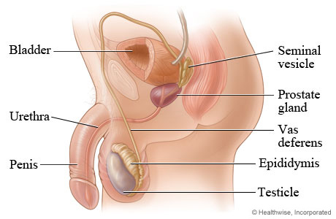
Semen is composed of fluid that mostly comes from the prostate and seminal vesicles with a small portion of its volume containing sperm from the testicles. Sperm are produced in the testicle and move to the epididymis to mature. During ejaculation they travel up the vas deferens and move to the prostate to mix with fluid from the seminal vesicles. Ejaculation then propels semen out of the urethra.

Normal volume of ejaculate is under 1 teaspoon, though even just this small volume can contain over 40 million sperm! The ejaculate changes from gel to liquid after a few minutes. Ejaculate volume tends to decrease as men get older.
Figure 7: Male reproductive anatomy (2022)

Pre-ejaculatory fluid can contain sperm, which means having unprotected vaginal intercourse and removing one’s penis from the vagina prior to ejaculation can still result in pregnancy.

Fun fact: Sperm count and quality are not impacted by tight underwear.

There are many ways to avoid pregnancy for those not interested in having children at the moment. These include condoms for men, condoms for women, diaphragms, birth control (which the female may take by pill, injection, place topically, or have implanted). For those interested in a permanent form of contraception, men may undergo vasectomy and women may undergo tubal ligation.

There are also many ways to help optimize fertility. The first is maintaining a healthy weight, through diet and exercise. Eating a balanced diet, focusing on fruits, vegetables, and lean protein will provide the vitamins and minerals important for healthy sperm. These vitamins and nutrients help naturally increase testosterone and remove harmful metabolites (known as reactive oxygen species).

Not only is maintaining healthy habits important, but limiting unhealthy habits is of equal importance. Drugs such as marijuana, cocaine, nicotine, and alcohol can reduce testosterone levels and sex drive. Not only that, but drugs can affect sperm directly by lowering concentration, quality, and damaging their DNA. The good news is that some of these changes can be reversed by stopping unhealthy habits.

Scrotal Pain
Pain involving the testicle (or any structure in the scrotum) can occur in men of any age. The scrotum contains two testicles (each one has the consistency of a hard boiled egg) and each testicle has an epididymis (feels like a chewed piece of gum on the back part of each testicle) and spermatic cord (cord-like structure that contains nerves, blood vessels, lymphatic channels, and the vas deferens). The vas deferens (feels like an al dente piece of spaghetti) is a tube that carries sperm from the epididymis into the pelvis.

Knowing the basics of the male genital and reproductive system is particularly important as testicular cancer (which typically presents as a nodule in the testicle with or without associated pain) is the most common cancer in American men between 15 and 35 years of age.

To best understand if/when there is a problem with one or both testicles, men should perform monthly testicular self exams. Cysts may develop in the epididymis, which are typically are NOT cancer and do not require any intervention unless they enlarge and become uncomfortable.

If you feel any hard lumps or bumps in one or both testicles, themselves, this would be a reason to seek evaluation by a healthcare provider. Pain may or may not be present. Usually the evaluation involves a physical exam and scrotal ultrasound. Testicular cancer is VERY treatable, so seeking evaluation early can help determine if there is a concerning mass and, if so, this can be addressed to optimize outcomes.

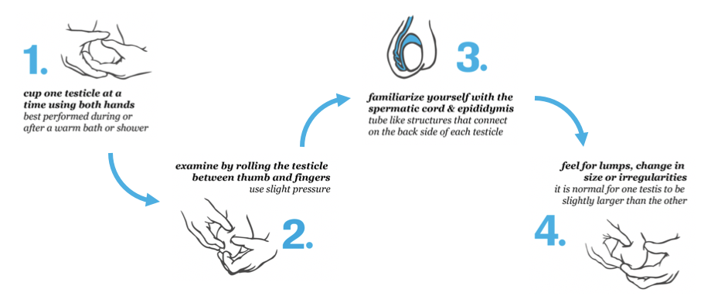
Figure 8: Testicular self-examination (2021)

Other causes of scrotal pain include torsion and epididymitis.
Testicular torsion is an emergency and presents with severe testicular pain, sometimes radiating to the lower abdomen. The testicle may become swollen and very tender. It is caused by the twisting of the testicle which cuts off its blood supply. Untwisting of the testicle under anesthesia in the operating room is usually needed to save the testicle. Intervention within 4-6 hours usually results in saving the testicle, but waiting longer can cause loss of the testicle.

Epididymitis presents similarly to testicular torsion with testicular pain that may radiate to the abdomen or back, but may also have infectious symptoms such as urinary frequency, pain with urination, testicular/scrotal swelling, skin redness, and/or fever. Infection of the epididymis is most commonly caused by an STI in college-aged men who are sexually active. In older men, urine infection is a more common cause.

Other reasons for scrotal pain (usually when it persists for several weeks/months) and is not associated with swelling or symptoms of infection, may be due to pelvic floor dysfunction (for which meeting with a pelvic physical therapist can be very helpful) and/or hip or back issues (for which meeting with a hip or back specialist may be helpful). If you have bothersome scrotal pain, you should seek evaluation by a healthcare provider to test for a bladder infection, STIs, and evaluate for the other causes of pain mentioned. Severe new onset scrotal pain should be evaluated urgently in case the testicle is twisted and requires urgent management.

Size
It is normal to wonder about the size of your penis and how it may compare to other penis-owners. In terms of what is considered to be a “normal” sized penis, there are varying statistics on the internet, but research has found that the majority of men have a penis smaller than 6 inches when erect.

Changes in penis size between the flaccid (soft) and rigid states may also vary. Some men may notice that their penis is the same length when soft and hard (“showers”) while others may notice significant increase in length and girth when erect (“growers”). This is due to the elasticity of the tissue. There is little to no correlation between height, body mass index (BMI), finger ratio, foot size, testicular volume, race, or age when it comes to penis size.

There are things that men can do to increase penis size (and others that are not recommended/safe). Excess tissue surrounding the penis can cover or bury inches of the penis. Losing weight for those who carry excess weight can help increase perceived penile length. Trimming pubic hair can also increase perceived penile length. Stretching devices are a method of increasing length, but may only provide a modest increase. When it comes to preserving penile length and girth, daily erections are important to maintain tissue health. Research suggests benefit of using traction/stretching devices to help restore length that may have been lost due to not getting regular erections or developing scar tissue in the penis.

Unfortunately, penis growth pills don’t work. In fact, they may even be dangerous! Fat and silicone injections, which are becoming a fad more recently, may lead to disfigurement and do not lead to a robust increase in length or girth.

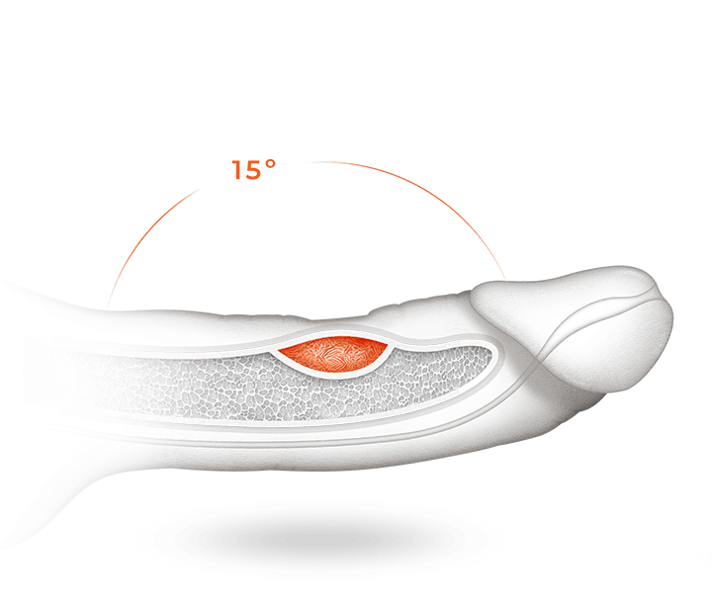
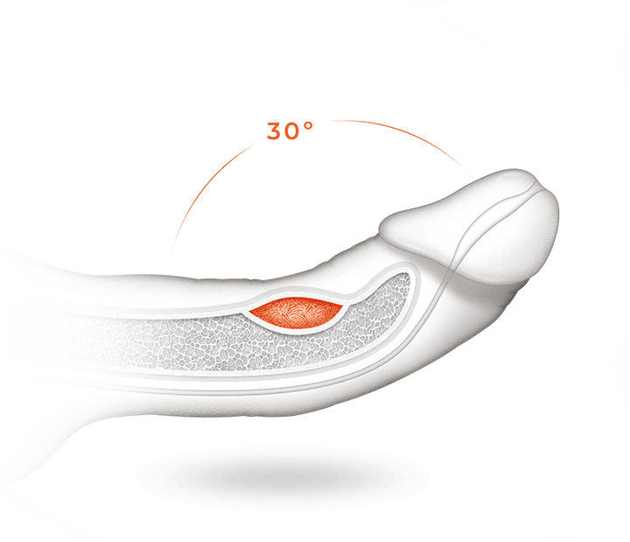
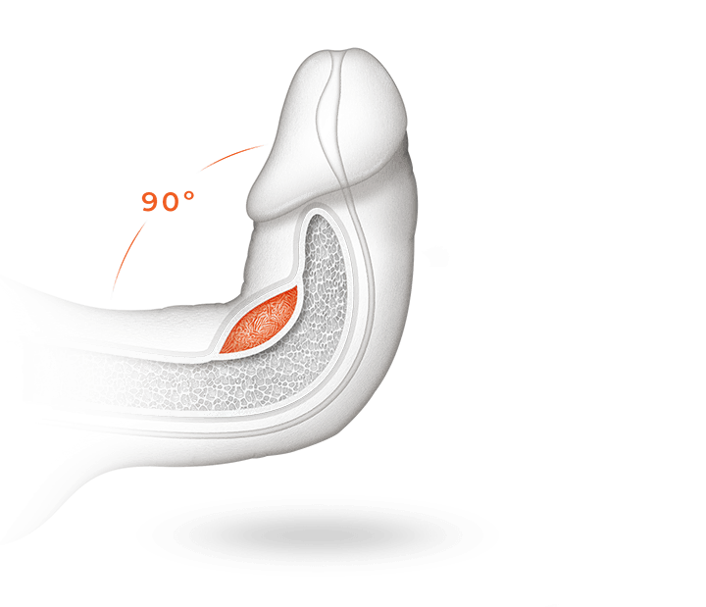
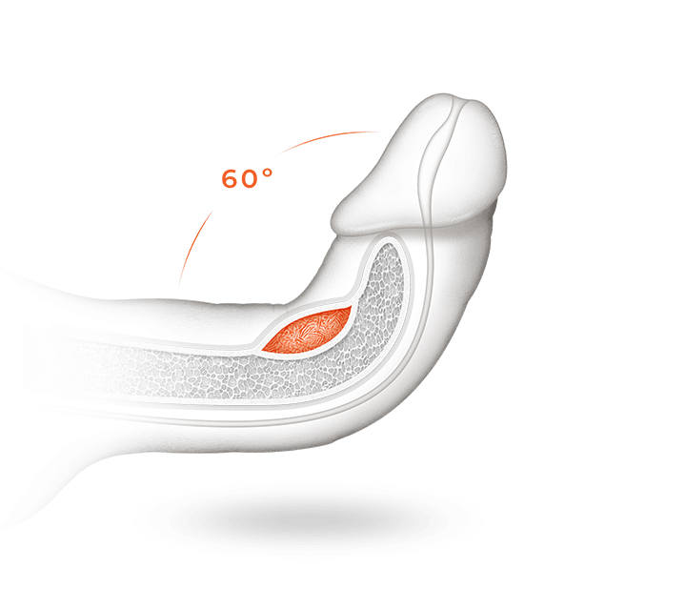
In addition to size, many men wonder about what a “normal” shape is. Some degree of curvature is normal and many men are born with this. As men get older, the shape of the penis may change or a curve may develop due to scar tissue. Curvature less than 30˚ typically does not require treatment. Reasons to see a healthcare provider urgently would be if you experience trauma/injury during any type of sexual activity that results in a “pop,” bruising/swelling, and or significant pain in the penis as this may indicate a tear in the tissue surrounding the spongy erectile tissue which is often fixed with surgery when found early. Other reasons to see a healthcare provider on a non emergent basis include changes in the penis (including penile pain, palpable scar tissue, and/or curvature) that causes problems for you and/or your partner.
Figure 9: Penile curvature and Peyronie’s disease (2022)

Not-so-fun fact: You can break/fracture your penis with sexual activity. It is important to engage in safe sexual practice when engaging in solo’d or partnered activity so as not to physically injure the penis.

There are treatment options for bothersome penile curvature, medical and surgical, including injections, traction devices, and surgery, to straighten the penis. Scheduling an appointment with a specialist in this field to discuss options can help alleviate the anxiety that often accompanies these concerns.

Image Citations:
Miller T 2020, Cross sectional anatomy of the penis, digital image, American Family Physician, accessed August 24th 2022, <https://www.aafp.org/pubs/afp/issues/2000/0101/p95.html>

Vacuum pump device 2017, digital image, Abdominal Key, accessed August 24th 2022, <https://abdominalkey.com/vacuum-erection-device-training/>

Tyagi S 2019, Penile prosthetic implant, digital image, Medical Treatment Centre, accessed August 24th 2022, <https://medicaltreatmentcentre.com/blog/penile-implants-a-ray-of-hope-for-men-suffering-from-erectile-dysfunction-to-get-back-on-the-track/>
Lower urinary tract symptoms 2020, digital image, Stream Dx, accessed August 24th 2022, <https://republic.com/stream-dx>

Benign prostatic hyperplasia 2022, digital image, Wikipedia, accessed August 24th 2022, <https://en.wikipedia.org/wiki/Benign_prostatic_hyperplasia>

Male reproductive anatomy 2022, digital image, HealthWise, accessed August 24th 2022, <https://www.cigna.com/knowledge-center/hw/male-reproductive-system-hw143376>

Testicular self-examination 2021, digital image, International Andrology London, accessed August 24th 2022, <https://london-andrology.co.uk/news/common-causes-testicular-lumps-swellings/attachment/self-exam/>

Penile curvature and Peyronie’s Disease 2022, digital image, Xiaflex, accessed August 24th 2022, <https://peyronies-disease.xiaflex.com/patient/penile-curvature-peyronies-disease/#curved-erection>

