If it is determined that a bloodborne pathogen (BBP) exposure has occurred, please utilize the following information to order source patient labs anonymously.

* Only the University Employee Health Clinic (UEHC), Integrated Call Center (ICC), ED, and those with approval from Student Health to draw exposure labs are authorized to order BBP labs.
  + If you are **not** authorized to order these labs, please call the STICK line at 319-467-8425. It is answered 24 hours a day, 7 days a week.
* These labs should always be ordered on the **source patient** after an exposure (some of these tests may be omitted if the source patient already has positive results in EPIC).
  + **Hepatitis B Surface Antigen (HBsAg) – light green, PST tube.**
  + **HIV Antigen/Antibody Combo – light green, PST tube.**
  + **Hepatitis C Antibody (HCA) – light green, PST tube.**
* If there is an existing **light green**, **red**, or **purple** top tube in Specimen Control within 72 hours prior to the exposure, labs may be added on.
* Source patients are not required to consent to testing in the event of a reported significant exposure.
  + Iowa state law requires that source patients be provided information, explaining that their blood will be tested. The EPIC order includes a link to an informational handout. The information in the handout **must** be provided to source patients or their legal guardian.
* All results are anonymous and are not filed in the patient’s chart. If the patient’s results are positive, their primary medical provider will be notified, and they will give the positive test results to the source patient.
  + Results are monitored through EPIC’s break the glass security feature monitored by the Compliance Office; UEHC, ICC, and ED personnel have been authorized to access the results.
  + All testing is at no cost to the source patient.

**Lab Order Procedure**

1. **Find EPIC order #LAB7513- POST BLOOD/BODY FLUID EXPOSURE- SOURCE PATIENT**
   1. The order may be found using search words: needlestick, BBP, exposure, needle, source, etc.
2. **Read the following statements in the order set and click acknowledge or answer the question:**

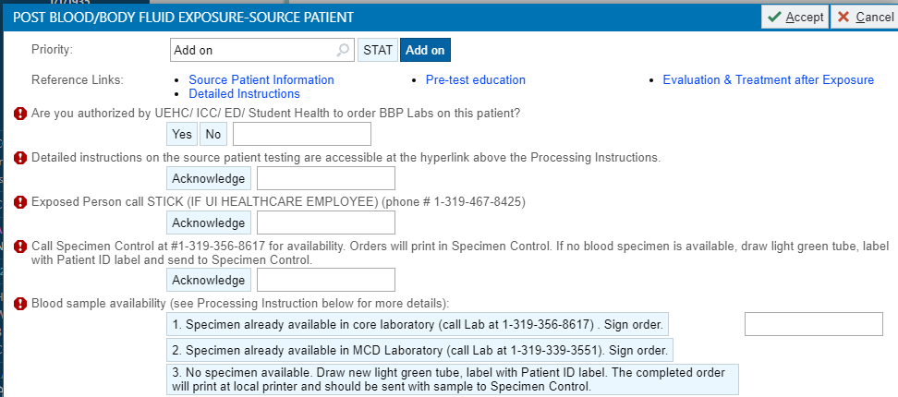

1. **Complete the next question by clicking on + Add.**



1. **You will get 4 drop-down options for labs.**
   1. All three labs can be ordered, or they can be chosen individually if the source patient has a known diagnosis of HBV, HCV, and/ or HIV. Select appropriately.

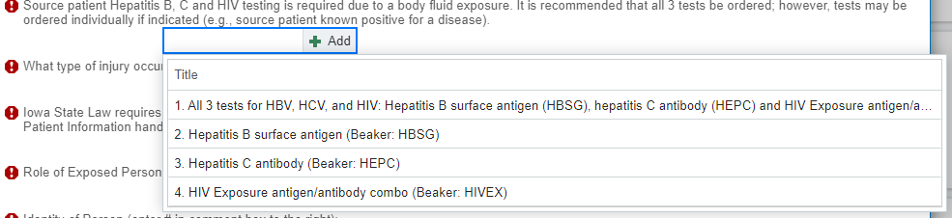

1. **Answer, or acknowledge, the following questions:**

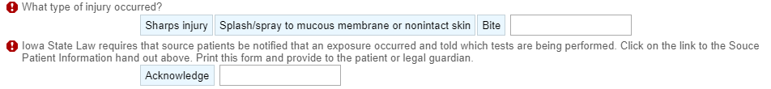

1. **For the next question, select the correct response on who was exposed:**

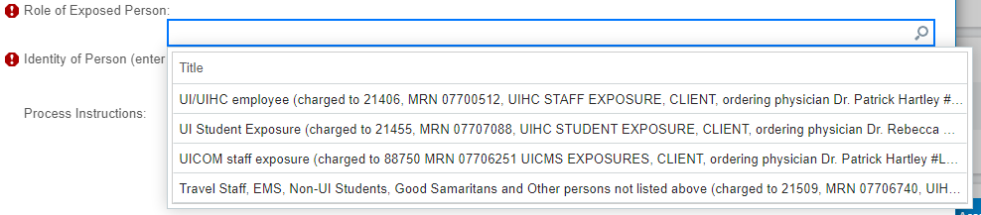

* **UI/UIHC employee**: includes paid staff/ employees and volunteers for the University of Iowa, and UI Health Care, including UI Community Clinics, Medical Center Downtown, fellows, and residents. Results always route to the Medical Director of the University Employee Health Clinic (UEHC) and are accessible by ED and ICC staff during off-hours.
* **UI student exposure:** includes all UI allied health students irrespective of Health Science College. Results always route to Medical Director of Student Health.
* **UICOM staff exposure**: For UI Occupational Health use. Includes UI Health Venture employees.
* **Travel staff, EMS, non-UI students, Good Samaritans, and other persons not listed above**: includes a variety of non-UI/ UI Health Care personnel. It can also include paramedics, transport personnel, law enforcement and other first responders. Typically, these exposures are handled in the Emergency Department and results route to the ordering provider.

1. **The next statement pertains to the exposed person’s identification and can be UI Health Care employee ID number or other (use MRN# or other reliable identifier for non-UI Health Care employees and volunteers).**

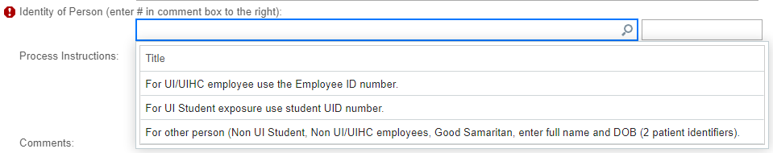

1. **Complete and sign the order.**
2. **Verify that the order is correctly placed under the Order Review section in EPIC. Make sure the order has been placed as a current order and not for future visit, as noted by the house icon.**

**Policies and Procedures**

This information aligns with current Iowa state law requirements for HIV testing, and UI Health Care policies:

* Clinical Care, Policy CC.P.24: Evaluation and Treatment of UI Staff, Volunteers, Students, and Agency Personnel Exposed to Potential Bloodborne Pathogens (BBP).
* Clinical Care, Policy CC.P.25: Policy Governing Human Immunodeficiency Virus (HIV) Education, Testing, Reporting, and Confidentiality.
* Infection Control, Policy IC.P.3: Exposure Control Plan for Bloodborne Pathogens.

**Contact Information**

For further information, or questions, please contact:

* University Employee Health Clinic
  + Phone: 319-356-3631
  + E-mail: [employee-health@uiowa.edu](mailto:employee-health@uiowa.edu)
* The Program of Hospital Epidemiology
  + Phone 319-356-1606